**Leader Overview**

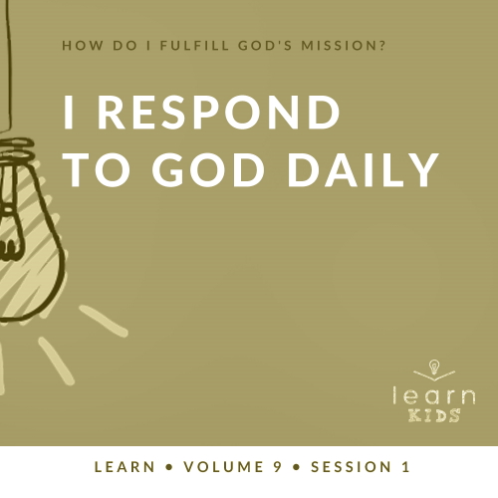

**Volume Overview**

**How do I fulfill God’s mission?**

*Christianity is so much more than only another religion. It’s not just another collection of rules and regulations. It’s a real relationship with Jesus Christ. When we give our heart to Jesus, He becomes our Savior and our Lord. Life is not only full of responsibilities, bills, and work, but it can also be full of eternal purpose.*

*As we grow closer to God, He begins to reveal His true purpose and plans for our life. We begin to discover the personal mission and assignment He has designed for each of us. While we may have different gifts, talents, and abilities, each of us is called to the same mission of helping to transform the world with God’s love and power. God calls us to personally share our faith, to help lead others toward a deeper walk with Christ, and to help others fulfill their individual mission. As we lean into God and allow Him to make a difference in our life, He will in turn use us to make a difference in the life of others.*

**Session Overview**

**I Respond to God Daily**

*Kids will discover that God chooses to use people to accomplish His mission in the world. He has plans for each one of us. Those plans include ways He wants to involve us in His mission. In the Bible story, God used a faithful man named Ananias. God’s plan seemed risky to Ananias, but he chose to be obedient and trust God’s plan.*

**Bible Lesson**

Ananias Responds to God

[Acts 9:10–18](https://ref.ly/logosref/Bible.Ac9.10-18)

**Faith Fact**

God has plans for my life.

**Faith Verse**

[Matthew 28:19](https://ref.ly/logosref/Bible.Mt28.19) (NLT)

“Therefore, go and make disciples of all the nations, baptizing them in the name of the Father and the Son and the Holy Spirit.”

**Preparing for the Session**

**Leader Preparation Time: 20–25 Minutes**

|  |
| --- |
| ***You Will Need***  ***Large Group***   * *Bible* * *Worship songs (Song suggestions: “Tell His Story” lyric video by Yancy; “Real Love” lyric video by Hillsong Young & Free; “For the One” by Brian and Jenn Johnson; “Build My Life” by Passion)* * *For groups not using a phone or tablet only, add:*   *• Projector or TV*  *• Laptop*  *•* ***Faith Fact Slide***  *•* ***Faith Verse Video*** *or* ***Slide***  *•* ***Bible Lesson Video***  *•* ***Teaching Point Slides 1–3***  *•* ***Large Group Game Page***  *• Scissors*  *• Cup or bowl*  *• Tape*  *• LEGOs or a LEGO kit*  *• Paper or index cards, one per kid*  *• Pencils or pens, one per kid*  ***Small Group***   * *Bibles for kids in your group to share* * *Whiteboard* * *Dry erase markers* * *Whiteboard eraser* * ***Small Group Activity Page****, one per kid* * ***Small Group Activity Page Answer Page****, one per leader* * *Pencils or pens, one per kid*   *To access session content and videos from a computer, visit:* [*BibleEngagementProject.com/downloads*](https://bibleengagementproject.com/downloads) |
| ***Getting Ready***  ***Large Group***   * *Download videos and slides if needed.* * *Select worship song(s) and have them ready to play.* * *Read the Bible Lesson Scripture to prepare for Teaching Time.* * *Print the* ***Large Group Game Page****.* * *Cut apart the numbered slips.* * *Tape the four larger numbers to the wall, one in each corner.* * *Fold the smaller numbered slips and place in a cup.*   ***Small Group***   * *Write the Faith Verse on the whiteboard with the dry erase markers.* * *Print copies of the* ***Small Group Activity Page****, one per kid and one copy of the* ***Small Group Activity Page Answer Page*** *for the leader.*   *First time leading* Learn *for Kids? Check out the* [*Facilitator Guide*](https://0b769b0ed3569ef9d18b-f88d8272f61086866d50d048b43ef630.ssl.cf2.rackcdn.com/sites/biblengagementproject/Listen_Facilitator_Guide.pdf)*.* |

**Large Group**

**30 Minutes**

*See what’s needed at the beginning of the session.*

**Introduction**

Welcome, everyone! I’m so glad you’re here today. We’re learning all about how we can fulfill God’s mission to help people know Him better and get closer to Him. Today we’ll discover how God has plans for your life. How many of you have ever planned something awesome like a sleepover or a birthday party? (*Group response*) What kinds of things have you planned? *(Allow responses.)*

Those are all pretty awesome plans. God has plans for us too—every single one of us! His plans are exciting, wonderful, and world-changing. Today we’ll hear an amazing Bible story about someone who followed the plan God had for him and how it changed the world. Let’s get started!

**Faith Fact**

Here comes the important phrase I want you to remember today. Our Faith Fact is: **God has plans for my life**.

• *Show the* ***Faith Fact Slide.***

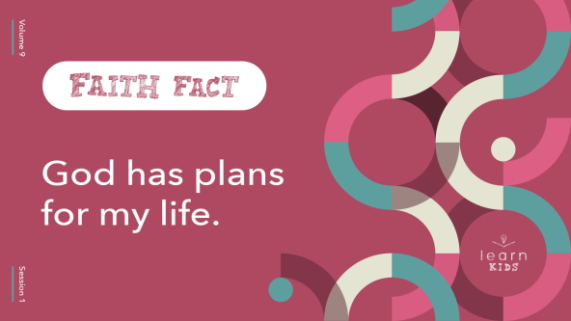

Let’s say the Faith Fact together a couple times to get it in our brain. First, point up and say it with me: **God has plans for my life.** Now point at yourself and say it one more time: **God has plans for my life.** Great job!

**Game**

**Four Corners**

|  |
| --- |
| ***You Will Need***   * ***Large Group Game Page*** * *Scissors* * *Cup or bow* * *Tape*   ***Getting Ready***   * *Print the* ***Large Group Game Page****.* * *Cut apart the numbered slips.* * *Tape the four larger numbers to the wall, one in each corner of the room.* * *Fold the smaller numbered slips and place in a cup.* |

Let’s play a game called Four Corners. Everyone will choose a corner in the room and go stand there. Then I’ll choose a volunteer to pick a number from the cup. If that number matches the corner you’re in, you’re out and must return to your seat. Let’s get started!

• *After each round, put the number slip back in the cup.*

• *Let remaining kids choose new corners and draw a number again.*

• *Keep playing until you have one winner or run out of time.*

• *Optional: If you don’t have much time to play the game, have kids choose a corner and stay there. Draw each slip and have kids in that corner sit down. When one slip is left, allow the remaining kids to move to a new corner and repeat until only one kid is left standing.*

• *Optional: If your group is too large to move around the room, have kids choose one of four actions instead of choosing a corner—stay seated, stand, sit on the floor, touch your toes, etc.*

Wow, you did a great job playing that game! Was it hard to pick the right corner? *(Group response)* How could you have known which corner would win or lose? It was totally random, right? *(Group response)*

Sometimes, we can look at the things that happen in our life—good or bad—and think they are just random luck. But if we do that, we forget something very important. God has a special plan for each one of us, and He cares about the things that happen to us! God wants each one of us to be close to Him and do great things for Him. Remember what our Faith Fact says? Say it with me. **God has plans for my life.** Great job!

**Worship**

I’m so thankful God cares enough about you and me that He has special plans for our life. Let’s thank Him for that as we worship Him today. Who’s ready? *(Group response)* Let’s worship Him together by singing.

• *Lead the kids in singing one or two praise songs. See suggestions at the beginning of the session.*

**Bible Lesson**

What an amazing time of worshipping God together! Now it’s time to learn from God’s Word and hear what God has to say.

Maybe you’ve wondered if God wants you to be part of His plan to reach people. God has big plans, and sometimes we feel too small to do much. But today we’re going to learn about someone who said yes when God told him to do something unexpected. Because of that, he didn’t miss out on his part in God’s plan. We’ll check it out right after we pray.

**Prayer**

|  |
| --- |
| *Dear God, thank You for letting us learn from Your Word. Please help us know how we can be part of Your mission. We want to make the most of the plans You have for us. Amen.* |

**Video Intro**

Before we look at the Bible story, let’s watch this video.

• *Play* ***Bible Lesson Video****.*

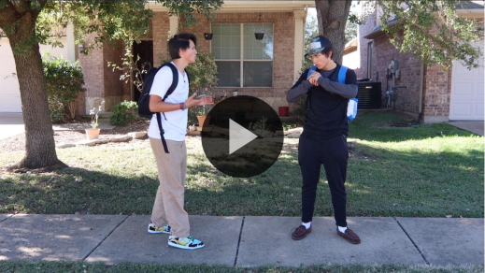

**Bible Story**

**Ananias Responds to God**

What a fun lead-in to our Bible story today! Remember when we talked earlier about planning a birthday party or sleepover? Imagine your friend invited you to a party and promised that there would be a fun and crazy surprise activity. Raise your hand if you would be excited about your friend’s plan. *(Group response)* Now raise your hand if you would be a little nervous. *(Group response)* How about excited and nervous at the same time? *(Group response)*

Thanks for your honest answers. The same thing can happen when we follow God. We usually don’t know every detail of what God is planning for us. That can make us feel excited and sometimes a little nervous too. In today’s Bible story, Ananias was kind of nervous to be part of God’s plan, but he was brave and obeyed God anyway. Grab your Bible or pull up a Bible app on your device. Turn to [Acts 9:10–18](https://ref.ly/logosref/Bible.Ac9.10-18) so we can check out the story together.

• *Read the Bible story aloud to the group.*

• *In order to keep Large Group time moving along, we don’t recommend having the kids read.*

• *Optional: Remind the kids to mark this place with their Bible Bookmark, so they can read it on their own at home.*

**Teaching Time**

|  |
| --- |
| ***You Will Need***   * *LEGOs or a LEGO kit*   *No prep needed for this activity.* |

Can you imagine what Ananias was thinking? God told him to meet a man named Saul—famous for putting believers in prison—and to pray for his healing! We can tell Ananias was nervous by the way he talked to God about Saul. But Ananias obeyed God anyway. He wanted to be part of God’s plan.

Ananias’s story shows us that God’s plans always work and we can be part of them. That’s why our Faith Fact is so important. Say it with me. **God has plans for my life**. Let’s say it together again as loud as we can. **God has plans for my life**. Here are three very important things you need to know about God and how His plans work.

**1. God uses people to do His work.**

• *Show the* ***Teaching Point 1 Slide.***

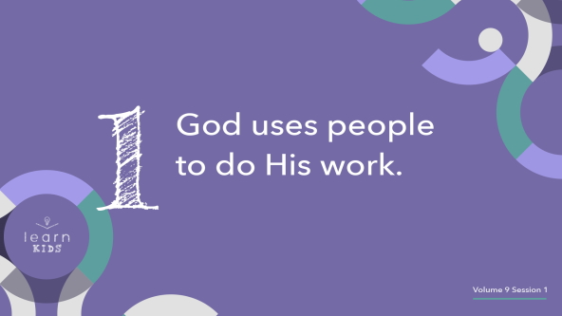

Why didn’t God just heal Saul? Why didn’t He send an angel to do the job? We see over and over again in the Bible that God uses people like you and me to do His work. Could God have healed Saul without Ananias? *(Group response)* Of course! So why do you think God used Ananias to be part of His miracle? *(Allow responses.)*

Something amazing happens when God tells us to be part of His work. When people like you and me help to fulfill God’s mission, we grow closer to God while helping other people grow closer to God too!

God may have been working on Ananias’s heart at the same time He was working on Saul’s heart. At first, Ananias was scared to obey God and find Saul. Maybe he had a hard time believing God would send him to such a terrible, dangerous person. But God was growing Ananias’s faith.

Imagine you had the choice to either build a big treehouse in your backyard or have the exact same one built for you. It might be easier to have it built for you, but think of how much you would learn if you built it yourself! You’d probably appreciate it more too.

That’s why God uses people to do His work. We discover who God is. We grow closer to God. And we get to see the amazing things God does in the life of another person.

**2. Sometimes God wants us to do challenging things.**

• *Show the* ***Teaching Point 2 Slide.***

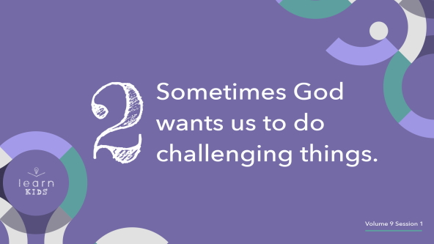

God told Ananias to do something that seemed risky and difficult. Ananias didn’t know how Saul would react. What if Saul had thrown him in prison or even had him killed? Going to pray for such a dangerous man must have been scary. But Ananias still chose to obey God. Because of that, he was able to be part of something great!

Just like He told Ananias, God may tell us to do challenging things too. Even if God’s plans seem difficult, scary, or too big for us, we can trust Him. If God wants us to do something, He has a good reason. We can know for sure that good will come from it.

It is totally normal to be scared of doing hard things. How many of you can ride a bike? *(Group response)* Think back to before you learned how to ride one. Were you scared to try it? *(Group response)* Maybe you felt pretty safe when you had training wheels, but it probably got a lot more challenging when they were gone! How many of you fell over when you were learning to ride a bike? *(Group response)*

Most people do fall over on their first few tries, but aren’t you glad you didn’t let fear keep you from trying? *(Group response)* We face many challenges in life—whether we’re learning new skills like riding a bike or doing the big tasks God gives us. Let’s not allow fear to keep us from chasing all God has for us to do.

In God’s plan for your life, you may have some moments like Ananias did. When you do, choose to be bold and brave and show someone God’s love. This is what it means to live every day on mission for God.

**3. God’s plan is always better than our own.**

• *Show the* ***Teaching Point 3 Slide.***

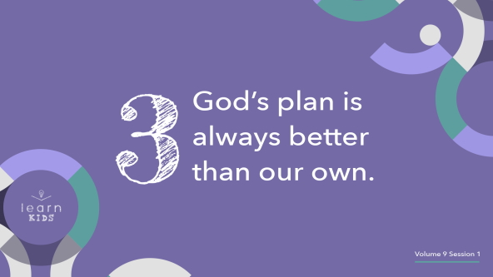

If Ananias had not obeyed God, we don’t know what might have happened. Maybe Saul would not have been prayed for or had his sight restored. Maybe Saul, or Paul as he was also called, would never have become a world-changing missionary. Or maybe God would have used someone else to pray for Saul. Here’s what we know for sure: It’s a good thing Ananias listened to God.

Ananias found out God’s plan is always better than our own. Sometimes we think our plans are best. We think we know better than God what we want or what we should do. But when we’re tempted to do things our way, let’s remember God always sees things we can’t. Let’s choose to trust Him and follow His lead.

Does anyone here like building with LEGOs? *(Group response)*

• *Build with LEGOs as you share the following.*

Some LEGO kits come with hundreds, even thousands of pieces! Thankfully, they also come with instructions. How else would we know how everything should fit together? Imagine you had a ten-thousand-piece LEGO spaceship kit. It’s cool that you can build whatever you want with LEGOs. But if you want to build the spaceship shown on the box, what do you need? *(Allow responses.)* That’s right! You need the instructions.

Even if you’re a super LEGO builder, you need the guidebook if you want your spaceship to look just like what’s on the box. Sometimes when you’re building with the guide, you have to put pieces together in a way that doesn’t make much sense. Maybe you start to think your spaceship won’t look like the picture on the box—until you get to the end. That’s when everything becomes clear.

The same is true with our life. Even when it seems like things don’t make sense, God is there to lead and guide us. We don’t always know how God’s instructions will fit into His big kingdom plan, but we can trust Him. If we follow God step-by-step, our life will line up with His plans for us.

**Prayer and Response**

*Consider playing a worship song softly in the background while kids pray.*

|  |
| --- |
| ***You Will Need***   * *Paper or index cards, one per kid* * *Pencils or pens, one per kid*   *No prep is needed for this activity.* |

When we think about God’s plan for our life, we can sometimes get a little confused. We might even believe any little mistake can mess up God’s plan. I’d encourage you to try this: Simply ask God what He wants you to do next. God didn’t give Ananias a giant plan with lots of steps. God told him to do one simple action: Go pray for someone. Let’s take some time today to ask God, “What do You want me to do next?”

• *Pass out the paper and pencils.*

As we pray, write down whatever you hear God saying to you. You’ll take the paper home with you to remember what God said. After a few minutes of praying on your own, we’ll pray together.

• *Take a few quiet moments for the kids to pray and write.*

**Prayer**

• *Optional: Have the kids repeat phrases of the prayer after you.*

|  |
| --- |
| *Dear God, thank You for having a plan for my life. Help me follow it by listening to You every day. Help me be bold like Ananias so I’m not afraid to do whatever You tell me to do. Amen.* |

**Faith Verse**

Our Faith Verse reminds us to fulfill God’s mission by sharing the truth of His Word with the whole world. Let’s say our Faith Verse and do the actions together.

• *Play* ***Faith Verse Video****.*

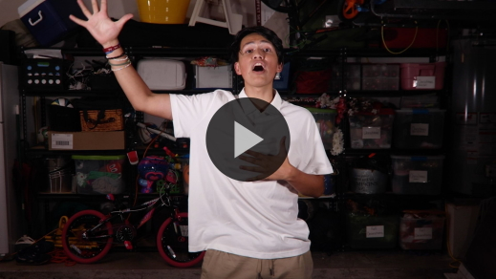

[Matthew 28:19](https://ref.ly/logosref/Bible.Mt28.19) (NLT)

“Therefore, go and make disciples of all the nations, baptizing them in the name of the Father and the Son and the Holy Spirit.”

Remember that one of God’s greatest plans for all of us is sharing the good news of His love with others!

**Faith Fact**

Before we go to our small groups, let’s say our Faith Fact one more time.

• *Show the* ***Faith Fact Slide****.*



Say it with me. **God has plans for my life.** God wants to use each one of you to help people in amazing ways. You might be the next Ananias, helping someone like Saul. Or you might be the next amazing world missionary like Saul would become. Keep trusting God, and He will keep leading you.

• *Dismiss kids to Small Group time or to go home if your group time ends here.*

**Small Group**

**30 Minutes**

*This section can be done in conjunction with the large group or on its own if you do small groups with your kids. During Small Group time, the goal is to connect the kids with the Word of God and to each other. All activities are led by the small group leader.*

**Group Connection**

**Hot Cold Clap**

Many people wonder how they can know God’s plan for their life. We probably won’t hear God’s voice with specific instructions about everything we’re supposed to do every day, but we can still know His plans for us in a couple of different ways. First, we can learn what the Bible tells us to do. And second, we can listen for God to speak to us and give us guidance and direction. He speaks, and we should listen!

Today, we’ll practice following directions, even if they aren’t super clear. I’ll pick someone to be the “Finder.” That person will wait outside the room *(or close their eyes)* while the rest of us choose an object in the room. Then the Finder will come back and figure out what we chose. The rest of us can’t use words to help the Finder—only clapping! When the Finder is far from the object, we’ll clap softly and slowly. The closer the Finder gets, the faster and louder we’ll clap! When the object has been found, we’ll try again with a different Finder.

• *Continue playing until everyone has a chance to be the Finder.*

That game was fun, wasn’t it? Here’s the point. The Finder had to constantly pay attention to our signals to figure out where to go and what to do, right? *(Group response)* We need to do the same thing with God. If we constantly listen to Him, we can live out the plans He has for us!

**Learn about It**

|  |
| --- |
| ***You Will Need***   * *Bibles for kids in your group to share*   *No prep is needed for this activity.* |

**Scripture Search:** [Psalm 33:11](https://ref.ly/logosref/Bible.Ps33.11); [Proverbs 3:5–6](https://ref.ly/logosref/Bible.Pr3.5-6); [Romans 8:28](https://ref.ly/logosref/Bible.Ro8.28); [Ephesians 2:10](https://ref.ly/logosref/Bible.Eph2.10)

Let’s dig deeper into God’s Word and see what else He has to say. As we find and read these verses, let’s think about what they mean for our life today.

• *Give each kid a Bible and search for one or more of the Scriptures as a group together (as time allows). When everyone has found the Scripture, have one of the kids read it.*

• *After reading each verse or passage, ask: What does this Scripture mean for our life today?*

• *Pair kids who need additional help with older kids or start simple and look up the session’s Bible story Scripture:* [*Acts 9:10–18*](https://ref.ly/logosref/Bible.Ac9.10-18)*.* *Kids will get better at finding Scriptures the more they practice.*

• *Optional: Make this a competition to see who can find the Scripture first.*

**Bible Reading Tip**

There are a lot of pages in the Bible! Sometimes it can feel overwhelming to read them all. But if you read in small sections every day, you can definitely read through the whole Bible slowly but surely. That’s why Bible reading plans and checklists are so helpful! No matter what kind of plan you choose, the best part is getting in the habit of reading the Bible every day.

**Challenge**

I want to challenge you to find a Bible-reading plan that you can try. Maybe it’s reading the Gospels, the stories of Jesus’ life on earth, in a year. Maybe it’s reading the Bible every day for a week. Or maybe it’s reading the verse of the day on a Bible app. Reading God’s Word changes your life, helping you grow and become more like God, which is pretty amazing! God might even tell you one day to share a verse to encourage someone else.

**Faith Fact**

God’s Word is powerful, and it shows us what God wants us to do and who He wants us to be. That reminds me of our Faith Fact: **God has plans for my life.** Turn to someone sitting beside you and say it to them. **God has plans for my life.** Well done!

**Group Discussion**

*Feel free to use all or just a few questions as a jumping-off place for good discussion. Questions marked with * are designed for more conversation. Adjust the questions based on the age or maturity of your group. Typically, older kids will be able to dive a little deeper than younger ones.*

**Questions**

• *If small group activities are not immediately following large group time, you may want to read the Bible story passage before this discussion.*

* If you could have any job when you grow up, what would it be?

* Have you ever wondered about God’s plan for your life? Share some of your thoughts.

Why did Ananias seem afraid to pray for Saul?

* What stuck out to you most about this Bible story?

What are some ways we can be part of fulfilling God’s mission?

Why does God use people to do His work?

* What big or small things might God ask someone to do?

* Is it hard to know God’s plan for you? Why or why not?

* Is it hard to follow God’s plan instead of your own? Why or why not?

How should our life be different because we know God has a plan for us?

**Prayer Requests**

*Finish group discussion by sharing prayer requests and praise reports. Keep track of your small group’s prayer requests and review them each time you meet.*

**Prayer**

*Have kids pray for each other’s prayer requests.*

**Faith Verse Review**

|  |
| --- |
| ***You Will Need***   * *Whiteboard* * *Dry erase markers* * *Whiteboard eraser*   ***Getting Ready***   * *Write the Faith Verse on the whiteboard.* |

It’s time to talk a little more about our Faith Verse, [Matthew 28:19](https://ref.ly/logosref/Bible.Mt28.19). In this verse that we call the Great Commission, Jesus told us God’s plan to share His love with people around the world. Let’s take a look.

• *Show* ***Faith Verse Video****.*



[Matthew 28:19](https://ref.ly/logosref/Bible.Mt28.19) (NLT)

“Therefore, go and make disciples of all the nations, baptizing them in the name of the Father and the Son and the Holy Spirit.”

Whenever you wonder about God’s plan for you, just remember our Faith Verse and start there. You can’t go wrong with that plan! Let’s review our Faith Verse as a group a couple of more times.

• *Say the verse as a group a couple of times.*

**Faith Verse Fun**

**Word Wipeout**

Let’s take some time to really get this new verse down. We’re going to play Word Wipeout. After we all say the verse together, someone will go up to the board, erase a word, and then sit back down. We’ll say the verse again. Then someone else will erase another word. We’ll work together to keep saying the verse until every word has been erased.

• *Consider having each kid who erases a word lead the group as they recite the verse.*

Great job, everyone! Let’s keep this verse in our mind and heart. It reminds us of God’s mission for us.

**Activity Page**

**Find the Way Maze**

|  |
| --- |
| ***You Will Need***   * ***Small Group Activity Page****, one per kid* * ***Small Group Activity Page Answer Page****, one per leader* * *Pencils or pens, one per kid*   ***Getting Ready***   * *Print copies of the* ***Small Group Activity Page****, one per kid and one copy of the* ***Small Group Activity Page Answer Page*** *for the leader.* |

In our Bible story, God told Ananias to go to a house on Straight Street where Saul was staying. Let’s see who can finish the maze and get him there first!

• *Hand out the* ***Small Group Activity Pages*** *and pencils.*

• *Give kids time to complete the activity.*

**Dismissal**

If you ever wonder if God has a purpose for your life, remember this: God has a plan for each of us. God wants to use us in powerful, unique, and wonderful ways to tell others the truth about Jesus’ sacrifice and love. Let’s close in prayer.

**Prayer**

|  |
| --- |
| *Dear God, please help us to have confidence in Your plans. Even when we don’t know the next step in Your plan, help us remember our part in fulfilling Your mission—telling the story of Jesus’ resurrection and sharing Your love with the world. Amen.* |

**Faith Fact Recap**

• *Show the* ***Faith Fact Slide****.*



One important thing I want you to remember is today’s Faith Fact. I’m so glad we got to learn this powerful truth together. Let’s say it one more time. **God has plans for my life.** I’m glad you were here today. I can’t wait to see you next time**.**

• *Send home the* ***Small Group Activity Page*** *and prayer slip.*

• *Remind parents that there are* ***Family Devotions*** *available on the app to do with their kid.*

• *Tell everyone the date and time for the next session.*